David Youngberg
Econ 301—Bethany College

Lecture 01: Introduction & A Big Idea

- What is economics?
- Trade offs
  - The seen and the unseen
  - Opportunity cost—net benefit of forgone option
  - Accounting profit—revenue minus costs
  - Economic profit—accounting profit minus opportunity cost
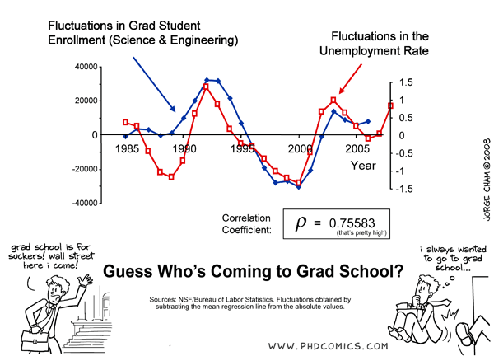
- Quick examples
  - Disasters and wars
  - Government spending
  - Barriers to trade and technology
- Optimal harm
  - Because we have trade-offs, all good things cost other good things. This sounds obvious, but it’s not.
    - Testing drugs kills people.
  - How much do you value your life?

